**Forensic Image Analysis**

Nwachukwu Edumanichukwu  
Bellevue University  
 CYBR 420-308H: Cyber Investigations and Forensics   
Professor Anthony Geron Tony  
26 February 2023

**A: IMG_3521**



**Location:** The image was taken at the C&A Industries Systems Lab located in Bellevue University, Bellevue, Nebraska.

**Date & Time:** IMG_1945 was originally taken on Mar 10, 2020, at 5:52:32 PM. It was later modified on May 19, 2021, at 9:50 AM.

**File size:** The File size is 1.1 MB.

**Device:** The model of the device used to take the photo was an Apple iPhone XS Max running an iPhone Operating System (iOS) 13.4.

**B: House.jpg**

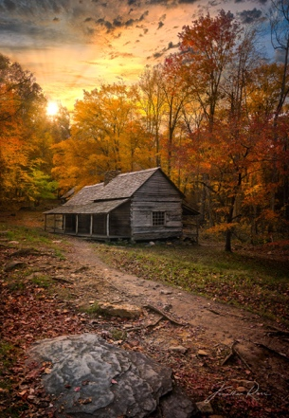

**Location:** This is the image of the Historic Ogle Log Cabin located in Gatlinburg, Tennessee. This cabin happens to be the first house that was built in Gatlinburg in 1802.

**Image Size:** 864 KB

**Credits:** This picture was taken by Jonathan Ross. The picture is named Sunset Near the Log Cabin.

<https://www.icanvas.com/canvas-print/sunset-near-the-log-cabin-jrp145#1PC6-26x18>

<https://www.tripadvisor.com/Attraction_Review-g60842-d1523959-Reviews-Historic_Ogle_Log_Cabin-Gatlinburg_Tennessee.html>

**C: IMG_3521.jpg**

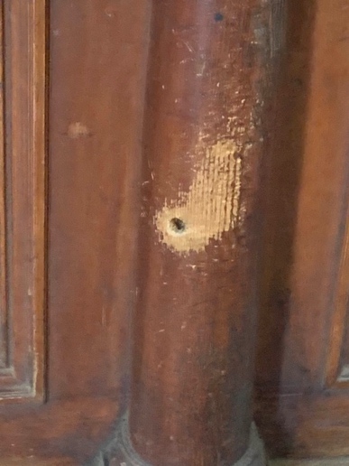

**Date & Time:** IMG_3521.jpg was originally taken on Nov 23, 2019, at 4:08:29 PM. It was later modified on May 19, 2021, at 9:50 AM.

**Image size:** 3024 × 4032 pixels

**File Size:** 497 KB

**Digital Zoom ratio**: 4.383

**Device:** The model of the device used to take the photo was an Apple iPhone XS Max running an iPhone Operating System (iOS) 13.3.

**Location:** The following coordinates “Latitude: 31° 42’ 44.022” N Longitude: 110° 3’ 54.37” W” was embedded in the metadate of the image. The coordinates was plugged into a google maps and I was directed to T. MILLER’S TOMBSTONE MERCANTILE, FINE WESTERN ANTIQUES & COLLECTIBLES which was located on the ground floor and the first floor is T. MILLER’S TOMBSTONE MERCANTILE HOTEL. The address is 530 E Allen St, Tombstone, AZ 85638. The location seems to be permanently closed.

**Altitude:** This place is 4,561.96 ft above Sea Level.

**D: Digging Out.**

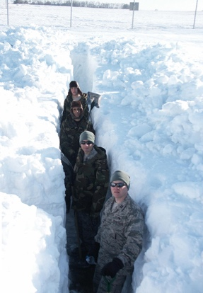

**Date & Time:** This image was modified on Dec 2, 2020, at 8:01 AM. I could not find metadata on the image of when the original date the picture was taken. However, On the website, the image was published on April 22, 2009, by Lt. Col. Robert A Fabian.

**Details:** The image is found on the website of the Minot Air Force Base. In this Picture, Members of the 91st Missile Maintenance Squadron prepare for Spring and work to ensure the functionality of the area.